Andrew Suh

MIST 5720 – (M) 3:30 PM

Mini Assignment 1 Report – Making a Website

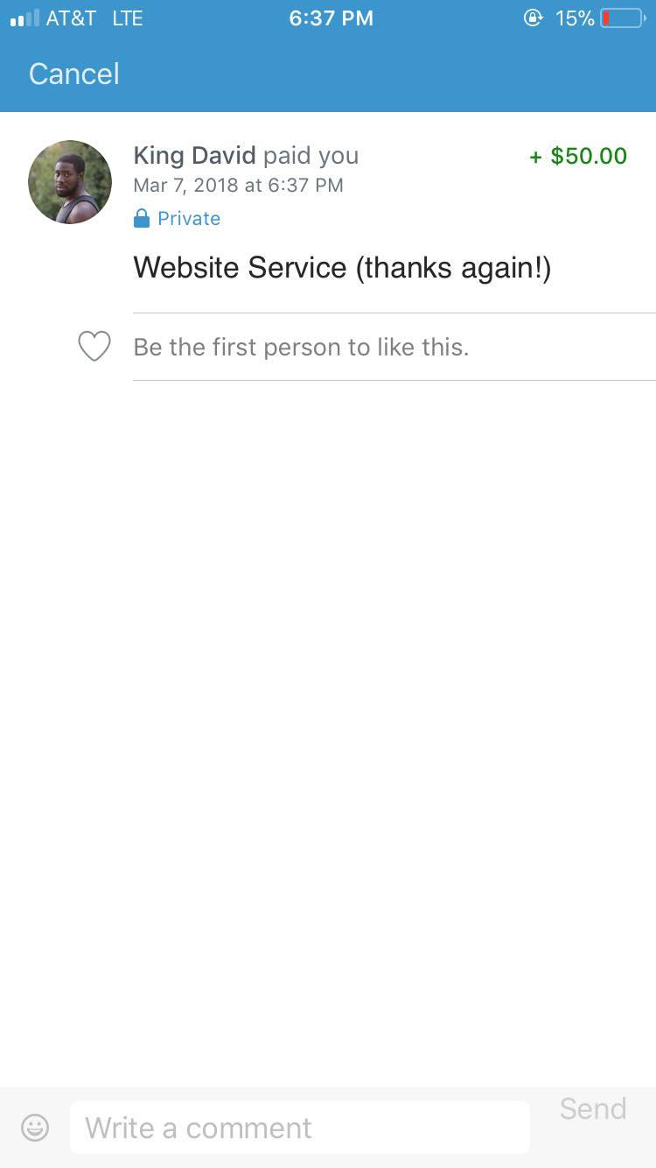I met King David, a 4th year student here at UGA who, turns out, is a very talented singer as well as the director of the UGA Accidentals, the university’s official male acapella group. A friend of mine referred him to me since he assumed I could do this kind of work. Even though I barely had experience or confidence with this kind of stuff, I took on the job since I knew it would count for a mini assignment. Back then, King was unsure about paying me since his funds at the time weren’t the best, but he paid me in the end. Picture proof provided below.

There were multiple factors regarding the lateness of this assignment, which I apologize again for.

I was inexperienced with making websites, so I had to spend quite a while relearning the general rules and coding conventions of making a website as well as new codes and features to make the website look as professional and official as possible (I had to look at Justin Bieber’s and Demi Lovato’s websites to get a better understanding of this). This included trying out multiple different fonts, testing multiple font colors to match the background picture and overall color scheme, rescaling the background picture to make it more rectangular and having it fit properly even on widescreen, implementing custom effects (ended up just going with fade-ins because slide-ins slowed down the website for some reason), and overall page dimensions and text sizes. Lastly, I had to work with graphics in various ways. I had to resize the Instagram and Facebook icons to have it fit with the text, and the background picture for the whole website was extended by me. What I mean by that, is I literally color shaded and extended the entire left side of the left tree by hand to make it look as if it was part of the original picture (the finished picture is titled “kingBack”, the original picture is titled “kingOG”). The website html files are also attached for you to view.

With that said, this was the website project I took on for King David. I apologize for the longer report and the ridiculous amount of time I took to finish this mini assignment. I hope what I’ve done is enough.